Curriculum Intent
Easter Sensory Tuff Tray

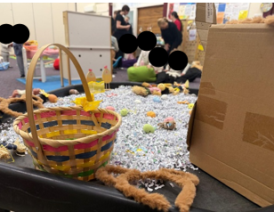
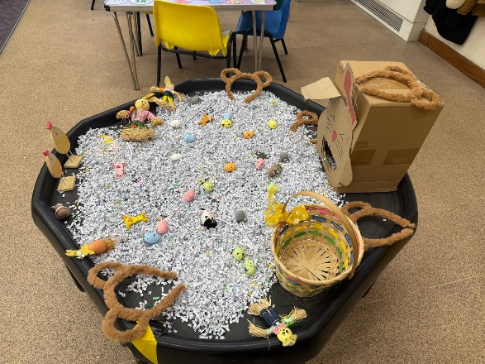
This Easter-themed sensory tray is designed to spark curiosity, imaginative play, and early language development through seasonal exploration. Children engage with shredded paper, eggs, chicks, and themed props to create their own stories, practise fine-motor skills, and explore texture and pattern. The provision supports Communication & Language as children describe what they see, use new vocabulary, and engage in shared storytelling. Personal, Social & Emotional Development is nurtured through collaborative play and turn-taking, while Understanding the World is enriched as children begin to make connections between cultural celebrations and the natural world. This setup reflects our intent to offer joyful, sensory-rich experiences that promote creativity, confidence, and meaningful engagement with seasonal learning.

Curriculum Intent
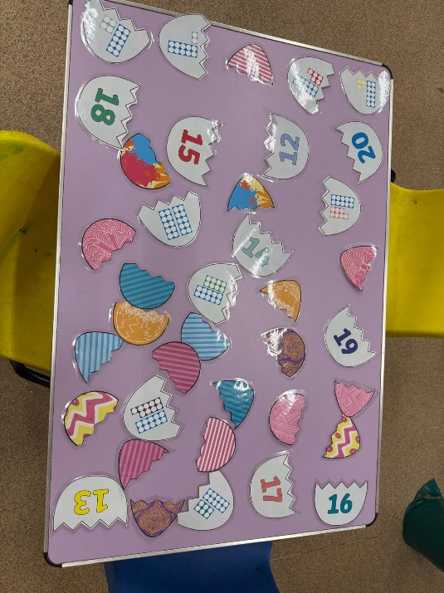
Number Matching Egg Activity
This number-matching egg activity is designed to strengthen children’s early mathematical understanding through hands-on, playful exploration. By pairing numbered eggshells with corresponding dot patterns and visual designs, children develop number recognition, subitising skills, and an awareness of quantity. The activity encourages children to compare, match, and problem-solve, supporting the development of early reasoning and mathematical vocabulary. Communication & Language is enriched as children talk about numbers, patterns, and their choices, while the fine-motor actions of handling and aligning the pieces support Physical Development. This provision reflects our intent to offer engaging, purposeful learning experiences that build strong foundations in early maths within the EYFS.

Curriculum Intent
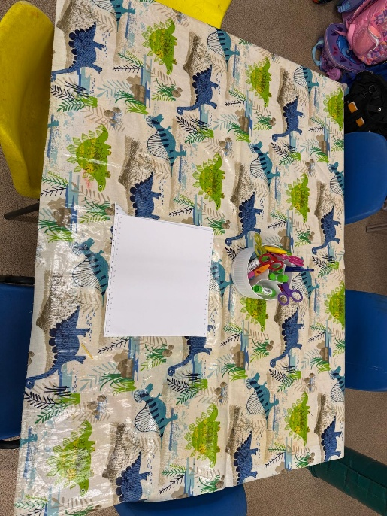
Creative Mark-Making & Craft Table
This creative mark-making and craft provision is designed to support children’s early writing, fine-motor development, and imaginative expression through open-ended exploration. By accessing a range of tools such as pencils, scissors, and colouring materials, children practise essential hand-control skills and develop confidence in making marks with purpose. The inviting setup encourages children to plan, create, and experiment, supporting Expressive Arts & Design as they explore colour, shape, and their own ideas. Communication & Language is enriched as children talk about what they are making, share choices, and describe their processes. This provision reflects our intent to offer accessible, well-resourced opportunities that nurture creativity, independence, and the foundational skills needed for early writing within the EYFS.

Curriculum Intent
Group Celebration & Community Event
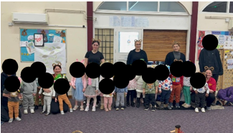
This group celebration is designed to strengthen children’s sense of belonging, community, and shared identity within the setting. By taking part in a joyful, themed event alongside peers and familiar adults, children develop confidence, social awareness, and emotional security. The experience supports Personal, Social & Emotional Development as children participate in group routines, celebrate together, and recognise themselves as part of a wider community. Communication & Language is enriched through conversations, singing, and shared storytelling linked to the theme. The event also provides opportunities for Understanding the World as children explore traditions, costumes, and collective experiences in an age-appropriate way. This provision reflects our intent to create inclusive, memorable moments that nurture relationships, promote wellbeing, and celebrate the uniqueness of every child within the EYFS.

Curriculum Intent
Easter Outdoor Exploration Walk
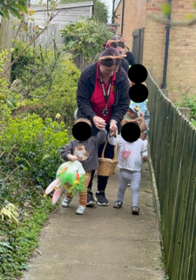
This Easter-themed outdoor walk is designed to promote children’s curiosity, physical development, and understanding of the world through meaningful real-life experiences. As children explore the outdoor environment, follow an adult-led trail, and carry themed items, they develop spatial awareness, coordination, and confidence in moving safely along different pathways. The experience supports Communication & Language as children talk about what they see, share excitement, and use new vocabulary linked to the celebration. Personal, Social & Emotional Development is strengthened through turn-taking, teamwork, and the shared joy of participating in a festive group activity. By connecting seasonal traditions with outdoor learning, this provision reflects our intent to offer rich, memorable experiences that nurture wellbeing, community, and a deeper awareness of the natural and cultural world within the EYFS.

Curriculum Intent
Outdoor Spring Celebration Walk

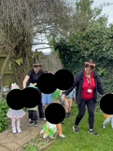
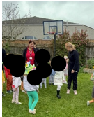
This outdoor spring celebration is designed to strengthen children’s sense of community, wellbeing, and connection with the natural world. As children walk together with adults, explore the outdoor environment, and engage in themed activities, they develop confidence, social awareness, and an understanding of shared traditions. The experience supports Personal, Social & Emotional Development through cooperation, turn-taking, and the joy of participating in a group event. Communication & Language is enriched as children talk about what they see, use new vocabulary, and share their excitement with peers. Physical Development is promoted through safe movement, coordination, and spatial awareness in an outdoor setting. This provision reflects our intent to create meaningful, inclusive experiences that celebrate seasonal learning and nurture children’s sense of belonging within the EYFS.

