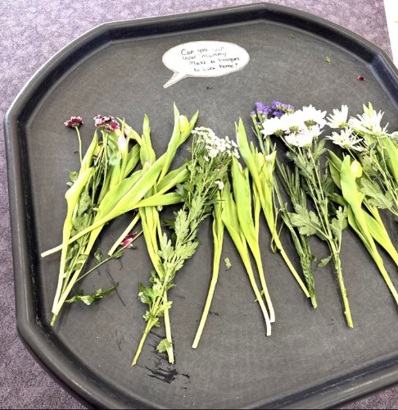

Learning Focus: Creativity, Fine Motor Skills, Communication, and Relationships
This activity invites children to explore real flowers, selecting stems, arranging colours, and creating their own bouquet to take home. Handling the flowers supports fine motor development through picking, holding, and arranging. The sensory experience of real petals, stems, and scents encourages curiosity and descriptive language. The prompt encourages shared interaction between children and their parents, strengthening relationships and promoting meaningful conversation. Staff should model gentle handling of natural materials, introduce new vocabulary (e.g., stem, petal, bouquet, fragrance), and support children’s choices without directing the outcome.

This setup encourages:

💐 Creativity
Children get to choose colours, textures, and shapes as they build their own bouquet.

🤲 Fine motor skills
Picking stems, holding bunches, and wrapping them all strengthen hand muscles.

👩‍👧 Parent–child bonding
The prompt invites shared time, conversation, and collaboration — a gentle, meaningful moment.

🌿 Sensory exploration
Real flowers offer:
- natural scent
- soft petals
- crunchy stems
- vibrant colours
- It’s a rich sensory experience.
🗣️ Language development
- Children naturally talk about:
- colours
- smells
- “big” and “small”
- “my favourite one”
- It sparks lovely conversations.

🌼 Parent Explanation
Today we invited the children to explore a selection of real flowers and create their own small bouquet to take home. This activity gives children the chance to choose colours, feel different textures, and enjoy the natural scents of the flowers. As they pick, hold, and arrange the stems, they are strengthening their fine motor skills and developing confidence in making their own creative choices.
Using real flowers also encourages lovely conversations — children naturally talk about what they see, smell, and like, and it creates a calm, shared moment between them and their grown-ups. The focus is on enjoying the experience together and celebrating each child’s unique little creation.

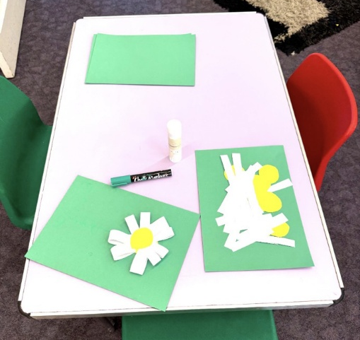
Learning Focus: Fine Motor Skills, Creativity, Early Maths, Language Development, and Understanding the World
This activity supports children in creating their own paper flowers using pre-cut petals and centres. As children pick up strips, position petals, and press them down with glue, they strengthen fine motor control and hand–eye coordination. The circular arrangement of petals introduces early maths concepts such as counting, shape, and spatial awareness.
The open-ended nature of the craft encourages creativity and decision-making, allowing each child to design their flower in their own way. Staff can model and extend vocabulary linked to the process, including petal, centre, stem, round, sticky, smooth, and arrange. Conversations about real flowers, colours, and seasons help children make connections with the natural world.
The focus is on exploration, confidence, and enjoyment of the creative process rather than producing a perfect finished flower

This setup supports:

🖐 Fine motor skills
Picking up strips, placing petals, and pressing them down with glue all strengthen hand muscles.

🎨 Creativity & design
Children choose how to arrange their petals and how many to use.

🧠 Early maths concepts
- Counting petals
- Understanding shapes
- Arranging items in a circle

🗣️ Language development
Staff can model words like:
- petal
- centre
- stem
- round
- sticky

🌼 Understanding the world
It links to real flowers, seasons, and nature.

🌼 Parent Explanation
Today the children created their own paper flowers using simple shapes and materials. This activity encourages them to explore colours, arrange petals, and use glue to build their flower in their own unique way. As they pick up the pieces and place them carefully, they’re strengthening their fine motor skills and developing confidence in using tools independently.
The craft also sparks lovely conversations about real flowers, seasons, colours, and shapes. Children naturally talk about what they’re making, which helps build their language and understanding of the world. The focus is on creativity, choice, and enjoying the process — every flower is different, and that’s what makes them special.

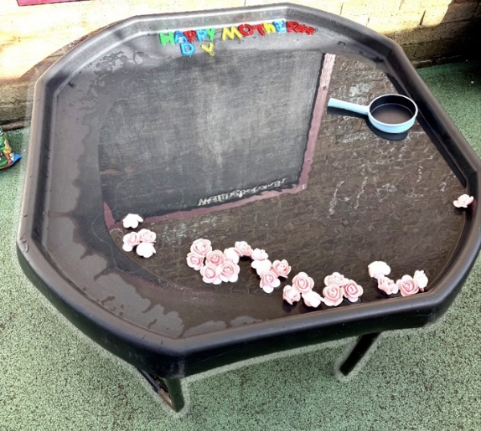

Learning Focus: Sensory Play, Fine Motor Skills, Language, and Understanding the World
This water-play activity invites children to explore floating flowers in a calm, sensory environment. Scooping and moving the roses strengthens fine motor control and hand–eye coordination. Staff can extend language by modelling descriptive words and encouraging children to talk about what they notice. The Mother’s Day theme supports conversations about families and special people. The focus is on gentle exploration, coordination, and meaningful discussion.

This setup supports:

🖐 Fine motor skills
Scooping, pouring, and moving the floating flowers helps strengthen hand muscles and develop hand–eye coordination.

🌊 Sensory exploration
Children experience the feel and movement of water, noticing how the flowers float, swirl, and drift.

🔍 Early scientific thinking
Observing what floats, how water moves, and how objects behave encourages early prediction, questioning, and investigation.

🗣️ Language development
Staff can model and extend vocabulary such as:
- float
- sink
- soft
- petal
- scoop
- cold
- 🤝 Social interaction
- Children practise turn-taking with the scoop, share space around the tray, and enjoy the calming experience together.
- 🌼 Understanding the world
- The roses provide a natural link to real flowers, celebrations like Mother’s Day, and conversations about special people in children’s lives.

Parent Explanation
Today the children explored floating roses in our water tray as part of our Mother’s Day activities. Scooping and moving the flowers helps develop fine motor skills, while the sensory experience encourages calm, focused play. The children enjoyed talking about the colours, textures, and the special people in their lives.

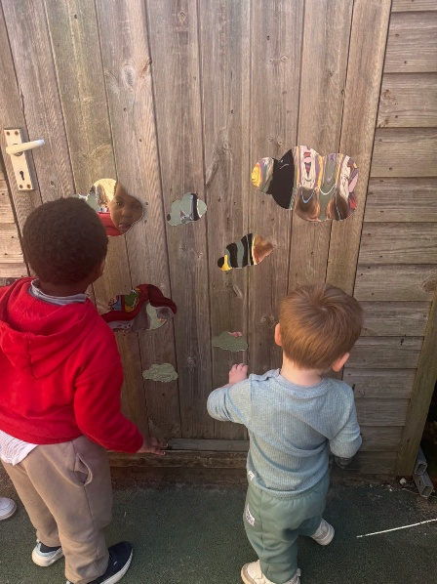
Learning Focus: Personal Development, Language, Self‑Awareness, and Understanding the World
This mirror exploration activity invites children to observe their reflections and notice how movement changes what they see. The wiggly mirrors encourage body awareness, confidence, and a sense of identity as children explore facial expressions, shapes, and positions. Staff can extend language by modelling descriptive words and encouraging children to talk about what they notice. The activity also supports social development as children laugh together, compare reflections, and share the experience. The focus is on curiosity, self‑recognition, and joyful exploration.of natural materials, introduce new vocabulary (e.g., stem, petal, bouquet, fragrance), and support children’s choices without directing the outcome.

This setup supports:

🧠 Personal, social & emotional development
Children explore their own reflections, building confidence, self-recognition, and a sense of identity.

🗣️ Language development
Staff can model and extend vocabulary such as:
- reflection
- wavy
- stretchy
- tall
- short
- funny

🏃 Physical development & body awareness
Children move their bodies, make faces, and experiment with positioning, helping them understand how their bodies work and move.

👀 Observation skills
The distorted reflections encourage children to notice differences, compare shapes, and talk about what they see.

🤝 Social interaction
Children naturally share the experience, laugh together, and comment on each other’s reflections, supporting communication and turn-taking.

🌍 Understanding the world
Mirrors help children explore cause and effect — noticing how their movements change the reflection and learning about how mirrors work.

Parent Explanation
Today the children explored our wiggly mirror panels, which distort reflections in fun and playful ways. The children enjoyed making faces, moving their bodies, and watching how their reflections changed as they moved closer or further away. Activities like this help build confidence, body awareness, and a sense of identity.
The mirrors also encouraged lots of conversation and shared laughter as the children compared what they could see. This supports language development, social interaction, and positive relationships. The experience was full of curiosity, joy, and self-expression.

